**Spike:** Task 9.P

**Title:** Game Data Structures

**Author:** Mitchell Wright, 100595153

**Goals / deliverables:**

To demonstrate an understanding of collection types, their strengths and weaknesses, and apply that knowledge in creating a functional inventory system.

Items created during task:

* Code, see: \09 - Spike – Game Data Structures\inventory\
* Report, see: \09 - Spike – Game Data Structures

**Technologies, Tools, and Resources used:**

* Visual Studio 2022
* SourceTree
* GitHub
* Lecture 2.2 – Game States & Stages

**Tasks undertaken:**

* Implementing Items
* Implementing the Inventory Class
* Implementing Viewing, Finding and Getting
* Implementing Addition and Removal
* Testing
* Commit to Git

**What we found out:**

1. Implementing Items:

An inventory needs items. I decided, then, that it would be a good idea to make an item. Here’s how.

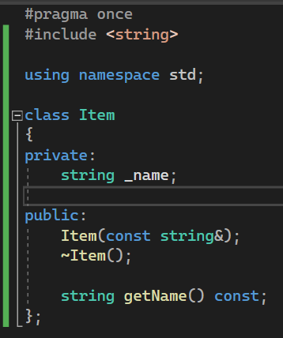

Items basically just have a name, constructor and getter. There’s nothing particularly special about this class, just a placeholder for future task.

1. Implementing the Inventory Class:

As per the brief, the inventory needed to support adding items, removing items, and viewing items. I did, however, decide to add onto this with finding (necessary for addition and removal) and getting (in case the item ever needs to be retrieved from the inventory) for later tasks involving Zorkish so that I have a head start. I’m going to be a bit upset if it was all for naught.

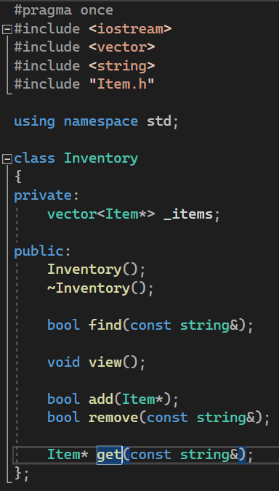

Using both the forbidden answer generator and my work from previous units, I tidied up things and added const where needed to avoid unnecessary copying. This was something I’d needed to be reminded of since I last worked with C++. Something noteworthy is my choice to use a vector instead of a map. This is partially due to my implementation of the items, with the names contained in them. Additionally, aside from vectors dynamically sized and efficient, the requirements of the inventory aren’t particularly complex. Adding, removing, etc., don’t require all that much coding and the basic checks needed to prevent errors are pretty basic too.

1. Implementing Viewing, Finding and Getting:

The simplest of the implementations in this seciton was viewing. Though I am tempted to go back and do it differently, making use of Ostream objects rather than letting the inventory handle it’s own IO. This is an approach I might take later on in the unit.

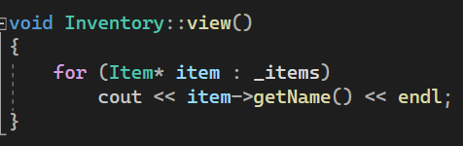

As shown above, it’s a simple for each loop, and a cout print. Nothing special.

In the case of checking if an item exists in the inventory, the below code uses another for each loop, checking if the item name matches the input name.

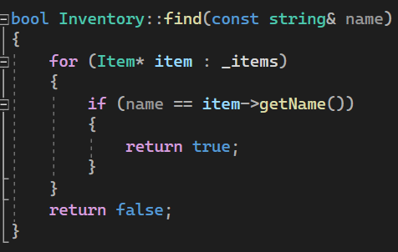

The reason I’ve done it like this, is due to using a vector for the items. Had I used a map, I could have also used the built in find function, however I like this.

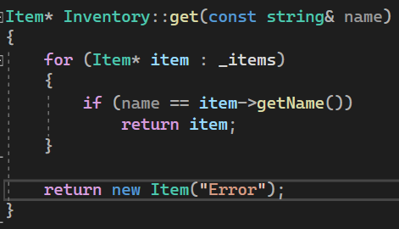

Getting works much the same, though rather than returning a Boolean, it returns the item or an item with name “Error”.

1. Implementing Addition and Removal:

Addition makes use of the push_back function provided by the vector, with a couple of protections and a boolean return.

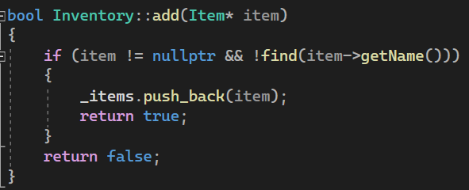

If the parameter fed through to the function is a nullptr or already exists within the inventory, then it isn’t added. This avoids duplicates with the same name.

Removal is a bit more complicated and once again, was optimised by the forbidden answer generator.

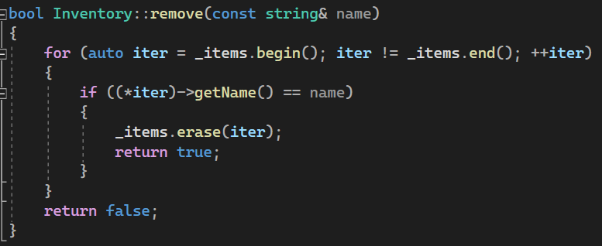

This method uses an iterator to loop through the items, then once the desired item is found, the item is removed and a bool is returned. Please also note the use of auto here and not in any previous part of the program. This is due to previous loops using pointers which supposedly may lead to unnecessary copies being made (according to VS2022’s warning messages).

1. Testing:

The test harness basically just goes through each of the above functions, testing a success state and fail state, as well as an edge cases at the end.

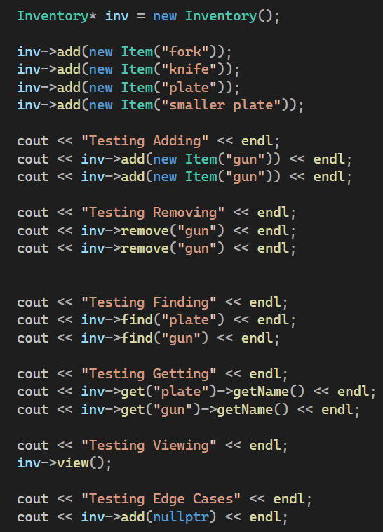

The program then prints these results.

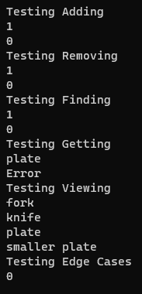

1. Commit History: